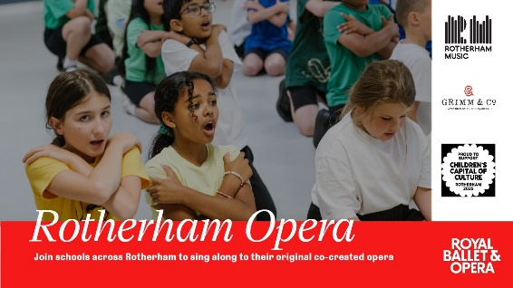

|  |  |
| --- | --- |
| School |  |
| Contact name |  |
| Email address |  |
| Preferred performance  (please highlight preference) | 25th November |
| 26th November |
| Estimated number of children attending |  |
| Estimated staff attendance 19th September CPD |  |

**Rotherham Opera – 25th and 26th November 2025**

**Join schools across Rotherham to sing an original opera!**

**The Royal Ballet and Opera, Grimm & Co, and Rotherham Music Service will be guiding primary, special and secondary schools through the creation of an original short opera, drawing inspiration from Mozart’s The Magic Flute.**

The CPD to introduce the songs and resources for this event will be on **Friday 19th September 2025** in person 9:30-3:30 (venue tbc) or online twilight session option the following week (23rd or 24th September tbc)

Estimated timings for the Rotherham Opera performance day:

* Arrive 9:30
* Leave 2:30

Please fill in the form below and return to [music@rotherham.gov.uk](mailto:music@rotherham.gov.uk) to book your place at this event.