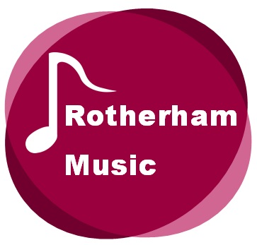

Rotherham Music

Taking an outcomes approach

Guidance on Rotherham Music’s Outcomes Framework
Adapted from the Youth Music Outcomes Framework
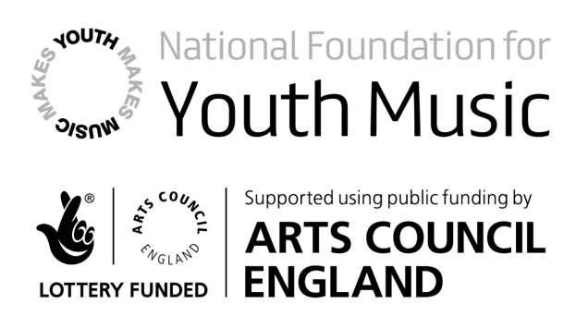

Contents
Taking an outcomes approach - Rotherham Music 4
Mission 4
Introduction 4
Why take an outcomes approach? 4
Taking an outcomes approach – a practical example 5
Defining the need 5
The planning triangle 6
Outcome indicators and methods 10
Rotherham Music Hub’s evaluation builder ⁵ 11
Learning and sharing information 13
Part 2: Rotherham Music Hub’s Outcomes Framework 14
How do I know which outcomes to choose? 15
How do I know whether outcomes are musical, personal, social, workforce or organisational? 15
Outcomes areas in detail 16
16
Musical outcomes 16
18
Personal outcomes 18
Social outcomes 20
Workforce outcomes 22
Organisational outcomes 24
Any questions? 25
Endnotes 26

Taking an outcomes approach - Rotherham Music

Mission
Rotherham Music provides a gateway to musical excellence, as defined in ‘The Importance of Music – A National Plan for Music Education’, enabling the children and young people of Rotherham to have access to a life that is enriched and inspired by high quality musical experiences. It ensures that children and young people have the best possible opportunity to engage with music making and music appreciation.
Rotherham Music is co-ordinated from Rotherham’s School Improvement Service where the mission, generated by school, academy and local authority leaders are:
• All students making at least good progress
• No underperforming cohorts
• All teachers delivering at least good learning and
• All schools moving to at least the next level of successful performance ( 1)
These high aspirations provide a common agenda which allows all providers to work together to create an environment for challenge and support in the delivery of learning opportunities; not least the provision of curriculum music, instrumental and vocal tuition as well as a wide range of additional music activity.

Introduction
To ensure we deliver the above agenda we have adapted the outcomes framework developed and by Youth Music, to underpin everything we do, guiding us towards achieving our vision. The outcomes approach is designed to help any organisation plan and evaluate their activities, and to measure the impact their intervention has on participants and stakeholders. Use of the outcomes approach is increasing right across the charity and cultural sectors and today we’re already starting to see the benefits of adopting this approach.
This guide explains the general principles of taking an outcomes approach, and will show you how to apply it to a Rotherham Music. Rotherham Music’s Outcomes Framework is an essential part of the funding application process. Following the guidance will help you to determine the musical, personal and social outcomes you want to achieve for young people, as well as the desired outcomes you want to achieve for your workforce and organisation.

Why take an outcomes approach?
Unquestionably, the evidence we have collected so far suggests that adopting an outcomes approach is beneficial. Sometimes, it can be difficult to visualise what impact you might achieve, or how to measure if it has been achieved at all! In its simplest form, the outcomes approach provides a framework for project planning, monitoring, and evaluation: its aim is to help you channel your efforts to where they can have the most impact. It forces you to think about change from the very beginning of your project.
Taking an outcomes approach helps you to:
- understand what changes are taking place and alter your activities accordingly to ensure that the most positive outcomes are achieved
- determine your overall progress in terms of impact, and what to scale-up, scale-down or stop altogether
- identify, learn from and share the parts of your project that did not go so well in addition
to the parts that went well
- secure further funding based on a robust and reliable evidence base.
If every project we support embeds an outcomes approach, then we can gain a better understanding of what is working and not working, with a view to sharing that learning with everyone else.
The basic principles that underpin the outcomes approach are similar to other planning and evaluation frameworks out there. You might have come across ‘plan, do, review’, ‘theory of change’, ‘action research cycle’, and other approaches to planning and evaluation. They are all closely related and follow a similar process.
In a nutshell, taking an outcomes approach requires you to go through five stages.
- Define the need for your project. Why should it exist in the first place?
- Define your intended outcomes. What are the changes you would like to bring about as a result of your project?
- Define you activities. What will you do to achieve those outcomes?
- Define your indicators. How will you know if you have achieved your outcomes?
- Evaluate. Review your progress, both good and bad. Learn from it and use this learning to inform next steps.

Taking an outcomes approach – a practical example

Defining the need
Before you think about the changes you want to bring about (i.e. the intended outcomes of a project), the first step is to understand why your project is needed in the first place.
Sometimes this starts out as a gut feeling, or you might simply ‘know’ there is a strong basis for taking action. But it’s important to break down these thoughts and feelings in order to really understand what kind of project is needed, and the extent to which your project can actually change anything. For this you need evidence.
The most important thing is to use a range of sources of evidence so that you can really understand what’s needed. You can then start to propose solutions and design your project.

Colourscape Project with Open Minds Theatre Company
Aims:
- To enable young musicians to play with and learn from professional artists
- To focus on improvisation, a process with which the young people will be less familiar
- To provide training in approaches to improvisation for Rotherham Music Service teachers
- To provide an interesting and rewarding addition to The Rotherham Show through performance in the Colourscape construction, a colourful inflatable, open to the public
Need and target group:
The Colourscape project gave young instrumental players, receiving tuition from Rotherham Music, the opportunity to work in a more creative way than they normally would do in their other musical activities.
Rotherham Music offers high quality tuition for children and young people in Rotherham which includes lessons in schools and weekly music centre activities such as orchestras and bands. We have offered workshops in the past in which we have explored improvisation but this is an area which needed expansion as we feel it is an invaluable part of the development of musicians. The need has been identified by teachers; this is an area of playing that is generally outside the ‘comfort zone’ of players who take the traditional route of tuition and is therefore something that they need some persuasion to take part in. The Colourscape project was designed include free improvisation, composition and exploration of world music and instruments. The project also included some training for Music teachers who would also benefit from the exploration of a method of teaching which they would maybe not normally employ in their lessons.
*This is an actual example of an application, but has been adapted to help you plan and evaluation your prosed project(s).

The planning triangle
The outcomes approach has been developed by the Charities Evaluation Service⁴ and we have adapted their planning triangle as a tool for you to use when planning your project. The triangle is split into three levels: the overall aim, intended outcomes, and activities.
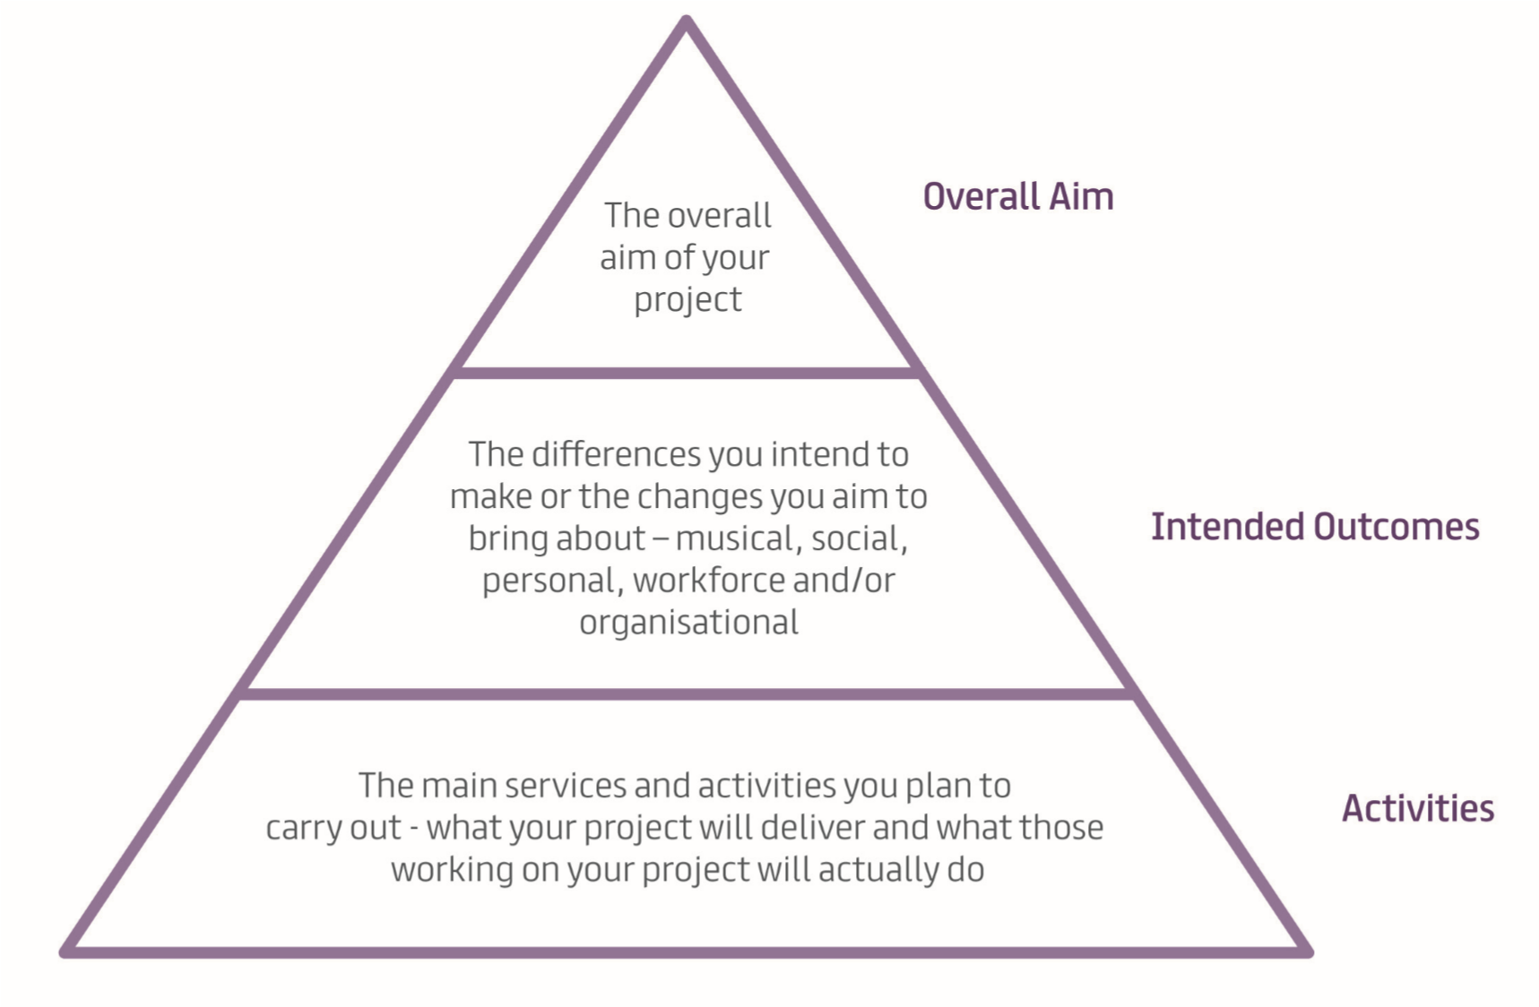
The planning triangle (adapted by Rotherham Music from the Charities Evaluation Service tool).
The aim: What is your project setting out to do? What is the overall change or difference you want it to make? Fundamentally, this explains why your project exists.
Intended outcomes: Your intended outcomes are the changes that you are aiming to achieve because of your project. What difference will it make, for example, for the young people taking part? The language you use to articulate the intended outcomes should involve words that reflect change: ‘increase’, ‘reduce’, ‘expand’, ‘enable’ ‘develop’, ‘improve’.
Your intended outcomes should be linked to the activities you will do (i.e. why are you doing the stated activities? What do you hope to achieve through delivering them?) The changes which result from your activities are your outcomes. Think about the time and resources you have available and the type of activities you will be providing: this will help you to devise outcomes that are realistic. They must relate closely to the activities you intend to provide (specific), be countable or able to be described thoroughly using research methods (measurable), and be achievable and realistic within the time and resources attached to the project.
The activities: What are you going to do that will bring about these changes? As mentioned above, these are the activities you will be delivering across the course of your project. While you use ‘change’ language for your outcomes (e.g. an improvement in singing ability), you should use ‘doing’ words for your activities (e.g. by providing 12 singing workshops).
The planning triangle allows you to think about each level and how they relate to each other. Will the overall aim of your project be met through achieving the intended outcomes? Will the activities you have planned realistically enable you to bring about the changes outlined in your intended outcomes? While some activities will help deliver on more than one outcome, it is critical that each activity is linked to at least one outcome, and that each outcome has at least one activity that will ensure your project delivers on it.
Use the Rotherham Music Hub Framework (detailed in Part 2) to help you think about what kind of outcomes you might want to achieve in a project. We expect all projects to work towards improving young people’s musicality directly, or supporting opportunities for them to develop their musicality through changes in the sector, so you might find it easiest to begin by thinking about musical outcomes. This may soon lead you to think about how the project may be working to develop young people’s personal or social skills too.
The outcomes framework is designed to be flexible: there is no specific combination of outcomes, or correct phrasing to be applied. The framework will simply help you to think through your outcomes and language, and provide an overarching structure.

Colourscape Project with Open Minds Theatre Company
Aims:
- To enable young musicians to play with and learn from professional artists
- To focus on improvisation, a process with which the young people will be less familiar
- To provide training in approaches to improvisation for Rotherham Music Service teachers
- To provide an interesting and rewarding addition to The Rotherham Show through performance in the Colourscape construction, a colourful inflatable, open to the public
Need and target group:
The Colourscape project gave young instrumental players, receiving tuition from Rotherham Music Service, the opportunity to work in a more creative way than they normally would do in their other musical activities.
Rotherham Music Service offers high quality tuition for children and young people in Rotherham which includes lessons in schools and weekly music centre activities such as orchestras and bands. We have offered workshops in the past in which we have explored improvisation but this is an area which needed expansion as we feel it is an invaluable part of the development of musicians. The need has been identified by teachers; this is an area of playing that is generally outside the ‘comfort zone’ of players who take the traditional route of tuition and is therefore something that they need some persuasion to take part in. The Colourscape project was designed include free improvisation, composition and exploration of world music and instruments. The project also included some training for Music Service teachers who would also benefit from the exploration of a method of teaching which they would maybe not normally employ in their lessons.

Activities:
We were approached by Open Minds Theatre Company to join with them in a project involving professional musicians in workshops and a final performance.
Young instrumentalists taking part in regular tuition and ensemble work with Rotherham Music Service were invited to participate in the programme of workshops; participation was entirely voluntary.
Four workshops were delivered after school hours and young people were given the opportunity to learn about improvisation and to experience less familiar instruments.
A half day training event was delivered to Rotherham Music Service staff.
In this example you can hopefully see how the activities have been checked against the intended outcomes to ensure that the proposed changes will take place.
Outcome 1
To encourage young people to be more creative and feel comfortable to freely improvise, compose work and to explore world music and relevant instruments. (Musical outcome)
Indicators: Talented young Rotherham musicians feely improvising, writing compositions and engaging with world music.
Outcome 2
- To develop the practice of Music teachers to be able to encourage learners to freely use improvisation, create composition and engage with world music method. (workforce outcome)
Indicators: Staff confidence to bring opportunities for free improvisation, written composition and reference to world music into their practice. We will design a short survey regarding measuring confidence levels at the beginning and end of the project regarding making changes to their practice
For outcome 2 (workforce development) the workforce will benefit from their direct participation in the project and will have the confidence to bring improvisation into their practice and be able to draw upon the knowledge of world music.
Outcome 3
- Increase organisational flexibility through staff embedding new practice into their delivery (workforce and organisational outcome)
Indicators: Staff attendance at the free CPD sessions running alongside this programme. Using a focus group after the final performance, we will ask Rotherham Music Service staff how they will embed the new practice into their delivery to enable the service to be more flexible in its approach.
For outcome 3 (workforce and organisational development) there will be embedded learning through the skilling-up of staff and an increase in service flexibility, by being able to offer different approaches to delivery.
When planning your own project think about all the different ways that your activities might bring about the outcomes, and be sure to discuss and describe how different ways of doing things could lead to different results.
The biggest oversight we tend to see in project planning and applications is a lack of detailed consideration as to how activities will bring about outcomes. It’s important to really think about why certain things are happening in a project, and their order and priority. While developing your application it is always useful to look over and refine your outcomes, as well as ensuring that all activities are necessary and all outcomes have activities associated with them.

Outcome indicators and methods
Before your project starts you will need to decide what information you want to collect to provide evidence of your progress towards achieving your outcomes (indicators) and how to collect the information needed (methods). As with setting your outcomes, it is important that you’re realistic about the number of indicators you decide to monitor and what kind of information you will be able to collect. We suggest aiming for at least two indicators per outcome to ensure you are using a range of evidence to judge what is happening in your project.
When thinking about indicators remember that identifying what you need to track or measure will usually be quite obvious in the outcomes language you have already used. For example, if you are aiming to develop young people’s composition skills you need to think about how you will know whether these have developed. This might involve asking participants to describe their skills, or arranging an external observation or assessment of these skills, or listening to compositions from earlier and later in the project – all of these approaches could demonstrate a change in composition skills – but composition skills is the indicator we need to track and evaluate.

Maybe you already collect certain kinds of information as part of your monitoring systems that you could use? Perhaps you could tweak the monitoring system you already use by rewording or adding questions that relate to a certain indicator? However, you may find that you need to find a new way of collecting the information. If you are looking at change you will need to think about collecting information at two time points (at/towards the start and at the end of the project). Having a baseline (i.e. an understanding of where the skills, knowledge, and ability of participants are at the beginning of the project) is important to demonstrate how much they have developed, as well as knowing what their development needs are.
When thinking about your indicators you will naturally start to think about the methods you will use to collect the information. This is fine, but remember that indicators are what you will be looking at and measuring – not how you will do it.
Some popular methods (i.e. not indicators) are:
- Recorded observation of participants
- Self-assessment questionnaires
- Diaries which participants or practitioners keep as part of the project
- Notes kept by project leads
- Interviews
- Focus groups
- Audio or video recordings of participants’ work at different stages

Rotherham Music’s evaluation builder ⁵
To support projects in selecting and measuring indicators we have created the Rotherham Music evaluation builder based upon the Youth Music’s evaluation tool. This is available online httpsXXXXXXXXX. This is an online tool which contains a number of validated measures you can use to assess the most common outcomes and indicators that Youth Music funded projects have previously used. This includes measures of musical ability for early year’s children, musical ability of 6-10 year olds, and musical ability of older children and young people, agency and citizenship, wellbeing, attitude and behaviour, and a range of measures relating to practitioners. You can select any of the questionnaires that might be appropriate to use in your project and create a bespoke downloadable PDF of all the tools and methods which can then be printed and shared with staff and partners. The evaluation builder also has guidelines for using qualitative methods, extended examples of how to analyse and interpret different types of data, and how to write-up findings.
Intended outcomes:
Outcome 1
To encourage young people to be more creative and feel comfortable to freely improvise, compose work and to explore world music and relevant instruments. (Musical outcome)
Indicators: Talented young Rotherham musicians feely improvising, writing compositions and engaging with world music.
Methods:
We measured impact by:
- Comparing the number of young musicians engaged with the project with potential numbers.
- Observing the confidence levels of young people with regard to free improvisation, composition and engagement with world music. Staff kept an observation diary to note how the young people were responding to the repertoire since the project.
- Assessing confidence levels by setting a short questionnaire at the beginning and end of the project.
- Monitoring the audience’s reaction to the final performance at the celebration event.

Outcome 2
- To develop the practice of Music Service teachers to be able to encourage learners to freely use improvisation, create composition and engage with world music method. (workforce outcome)
Indicators: Staff confidence to bring opportunities for free improvisation, written composition and reference to world music into their practice. We will design a short survey regarding measuring confidence levels at the beginning and end of the project regarding making changes to their practice.
Methods:
We measured impact by:
Design a short survey regarding measuring confidence levels at the beginning and end of the project regarding making changes to their practice.

Outcome 3
- Increase organisational flexibility through staff embedding new practice into their delivery (workforce and organisational outcome)
Indicators: Staff attendance at the free CPD sessions running alongside this programme. Using a focus group after the final performance, we will ask Rotherham Music Service staff how they will embed the new practice into their delivery to enable the service to be more flexible in its approach.
Methods:
We measured impact by:
- Monitoring staff attendance at CPD sessions
- Asking staff how they will embed new practice into their delivery, to be followed up with a questionnaire in 6 months’ time to see if they are still embedding the practice into their delivery.

Learning and sharing information
While much of the guidance so far has related to project planning and supporting your application to Rotherham Music Hub, it is important to remember that a strong outcomes approach is essentially about making project evaluation straightforward, meaningful and useful. When you are analysing and interpreting the data you collect as part of a project, try to think about what you - or others - might learn from it. This is also a useful way of framing some of the less positive things that might have happened, parts of the project that were challenging or didn’t go to plan. This can be the most valuable information to share with the Rotherham Music Hub, and with other projects, so people can learn from mistakes or approaches that haven’t had the desired effect.

Part 2: Rotherham Music’s Outcomes Framework
The Youth Music Outcomes Framework defines the five broad areas of change that we would like to support through project funding. The outcome areas you will be expected to work towards depends on the fund you will be applying for. The Outcomes Framework is not prescriptive, giving the applicant flexibility to define their own outcomes, indicators and activities.
We would like you to apply for funding with a very clear idea of what changes you are trying to bring about (i.e. your intended outcomes). We know that things don’t always go to plan, and there will be lots of outcomes that you can’t even imagine right now. However, we have seen that the most successful projects do well because those involved have a strong approach to project planning and a shared understanding of what they are trying to do, and how.
Rotherham Music funded projects work across five outcome areas. These relate to children and young people themselves (musical, personal or social outcomes), and to those supporting them (workforce and organisational outcomes).
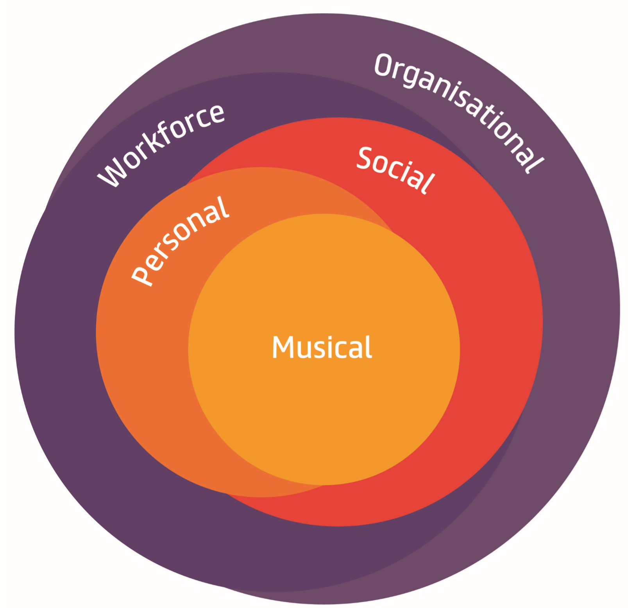

How do I know which outcomes to choose?
There are endless ways to bring about positive musical, personal and social development. The most important thing is to be appropriate to your participants’ needs and ensure that they have input into the project. Everyone will be on their own learning and progression journeys and you will be doing what you can to support their individual paths. That said, you will know from previous work and from consulting with participants which are the main areas of development you intend to focus on.
This applies to outcomes relating to the workforce or organisations too. Think about where you and your colleagues are now, and where the evidence tells you that funding is needed to improve things.

How do I know whether outcomes are musical, personal, social, workforce or organisational?
The following guidance describing the outcome areas in detail should help make sense of which outcomes relate to which outcome areas. We know there is a great deal of cross-over between outcomes – learning to play a musical instrument may increase confidence (and performing in front of others might change the perceptions of a community) – all of which needs to happen with the support of excellent practitioners and organisations.

Setting and measuring outcomes is not an exact science, but thinking clearly about the potential effects your activities will reveal just how many different outcomes you might achieve. This process is simply about structuring the work in a sensible and measurable way. However, It is true that the fewer outcomes you are working towards, the simpler the process.
Example outcomes
- To increase the musical skills and confidence of all participants (musical)
- To increase participants’ knowledge of new musical cultures (musical)
- To improve the communication skills and empathy of all participants (personal)• To increase the community’s awareness of participants’ musical achievements (social)

You have the freedom to choose which combination of outcome areas you think is needed by your project, and the freedom to write your own intended outcomes. However, we strongly recommend taking time to consider the full outcomes framework and having a clear understanding of what is needed before working on your intended outcomes for the project.

Outcomes areas in detail

Musical outcomes

What are musical outcomes?
Musical outcomes are those relating to any aspect of musical development: this can include people’s musical skills, knowledge and abilities. Everyone has some level of musicality and we are looking for projects that build on this in a way that is appropriate for the participants. When working towards musical outcomes we want projects to be specific about which aspects of musicality they are looking to develop.
Suggested outcomes language
- Developing technical skills and abilities – instrumental, singing, composition, improvisation, performance, technology
- Developing musical understanding and communication – expression, creativity, listening, interpretation, evaluation
- Developing knowledge and understanding of musical worlds and roles
– experiences, musical cultures, the music business, music leading
How are activities linked to outcomes?
There are lots of different approaches that will bring about different musical outcomes. It’s important to think these through and consult with participants before, during and after any projects, and to explain why you will try certain approaches in your application.

You might want to work in small groups to begin with if the participants aren’t feeling

particularly confident; you can then gradually work out who wants to develop in which
ways and which kind of approaches might work for different participants. You might want to work out participants’ musical interests and knowledge by asking them about music they listen to, or you might want to surprise them by playing something you think they will never have heard. All of these approaches will engage young people and help them to build confidence and trust (while developing musical understanding and knowledge), before you focus on more technical skills and abilities.
When you are working on a technical skill, remember that the participant will be likely to have an idea of how they would like this to develop. If you recognise you’re in it together and can be flexible to each other’s interests and learning intentions you might find that progression happens quite quickly!
Also remember that there is more to being a musician than playing an instrument. There are all sorts of visits, experiences and perspectives that might help participants to understand what being musical and being a musician is all about.
How can I measure and evaluate these outcomes?
Rotherham Music Hub’s evaluation builder (available on the Youth Music Network)contains a musical development scale which you can use to measure self-perceived musical ability at various stages of a project (e.g. beginning-middle-end), either using a survey or by talking to the young people.
You might want to encourage the music leaders to keep a diary or record of how they feel the participants are progressing musically. You could use qualitative methods like interviews and focus groups, where participants are asked to reflect on various aspects of their musical development. Don’t forget that the music itself can be fantastic evidence of musical development: some of the best evaluations include clips and excerpts of the music played and who it was performed by at various stages of their development

Personal outcomes

What are personal outcomes?
Personal outcomes are those relating to any aspect of personal development: this can include people’s skills, knowledge and abilities. Personal outcomes relate to how people feel about themselves, how they might be able to do things they weren’t able to before, or how they have developed their understanding of the world. This includes educational development and emotional development. Personal development is also strongly linked to social development and both are strongly linked to musical development.

Suggested outcomes language

- Developing extrinsic outcomes like individual achievements and behaviours - literacy, language, numeracy, planning and problem solving, transferrable skills, knowledge of support available, work experience
- Developing intrinsic outcomes like emotional and psychological capabilities - communication, confidence, agency, self-efficacy, creativity, resilience, motivation, managing feelings, empathy, self-awareness

How are activities linked to outcomes?

It is particularly through being supported in musical learning that participants develop many extrinsic and intrinsic outcomes:
A young person learning how to write hip-hop rhymes and make beats may develop literacy and language skills as well as gaining confidence, self-efficacy and self-awareness.
A young person being given the opportunity to develop composition and improvisation skills will also be likely to grow in confidence and become more creative in other aspects of their lives (i.e. thinking of other ways of doing things or applying what they know in different contexts).
Personal outcomes
A young person being given the choice of which genre or instruments they would like to learn and being supported to develop accordingly will also be likely to develop agency (i.e. feeling in control of their lives), feel listened to, and perhaps feel increased motivation.
A young person being encouraged to lead a music session with their peers will develop music leadership skills alongside planning and problem solving, self-efficacy (i.e. their competence and ability to achieve things).

How can I measure and evaluate these outcomes?
There are many ways to consider and measure personal outcomes throughout the life of a project. Our evaluation builder has a range of tools that have been designed to measure common personal outcomes, these can be applied either quantitatively (using questionnaires) or qualitatively (using interviews, focus groups or creative methods).

A number of project outputs can also be used to indicate personal development (e.g. accreditations, registers of attendance, performances, filmed interviews). The Young Foundation’s Framework of Outcomes for Young People also has a matrix of tools which have been validated for measuring and demonstrating personal outcomes across all kinds of projects: some of these might be relevant to your music project:
http://youngfoundation.org/publications/framework-of-outcomes-for-young-people/

Social outcomes

What are social outcomes?

Social outcomes relate to changes in a person or group of people that can have broader benefits for people and society beyond the individual. Social outcomes can be based on changes in a person, or can be based on changes in communities or environments that relate to a person or group of people. Thinking about why positive cultural, health and educational experiences and outcomes which improve many people’s lives are so important to individuals also helps us to think about broader social outcomes.

Suggested outcomes language
- Social outcomes can be considered from the perspective of the individual or group in terms of developments in team working, cultural understanding, community connectedness, personal relationships, group creativity and problem solving, communication.
- Social outcomes can be considered from the perspective of the community or environment in terms of use of resources (e.g. education, health care, criminal justice), community cohesion, perceived value and reputation of young people, family relationships, volunteering.
How are activities linked to outcomes?
Social outcomes often emerge when individuals are encouraged to work together or in groups - group creativity and problem solving can be developed when participants are asked to organise a musical event; communication and trusting relationships can be developed when participants are given opportunities to perform or improvise in an ensemble; working together to research or learn new genres of music can increase cultural understanding; group performances or concerts may engage audiences in the community who wouldn’t normally see young people doing something positive. Music is unique in allowing people to communicate with each other and develop their understanding without the need for language.
Social outcomes

Beyond working together, individual musical and personal development can also have broader social effects and outcomes: a person developing confidence and self-efficacy might begin to engage more at school, improving the school experience for their peers; a person being given regular opportunities to develop music skills may reduce negative behaviours (e.g. vandalism) which were affecting their community; an increase in certain individual practical skills may increase levels of volunteering in a community.

How can I measure and evaluate these outcomes?
Social outcomes can be measured using both quantitative and qualitative methods and it’s important to use a range of methods to be confident in the types and level of changes you think are happening. Questionnaires, interviews or focus groups with participants can be great ways to measure changes in team-working skills, cultural understanding, relationships and communication skills. Observing groups, using video or visual methods can be a good way to explore changes in group creativity, problem solving and communication.
To measure changes from the perspective of broader communities you might need to ask schools for data relating to attendance or engagement, or ask the local police or youth offending teams if there has been any noticeable changes according to their data or perspectives. You can also engage with parents, carers and other audiences to explore whether they have identified any positive social outcomes as a result of young people participating in project activities.

Workforce outcomes

What are workforce outcomes?
Workforce outcomes relate to the skills, knowledge and personal development of the workforce employed on a project. These aren’t direct changes in the young people you’re working with, but they add a great deal of value to the workforce and, by extension, the project and the participants. In all projects we would encourage you to think about the needs of the workforce and how to measure and evaluate their development.

Suggested outcomes language
- Most outcomes will relate to the skills, abilities or knowledge of the workforce, but it is important to be specific about which of these you are aiming to change (e.g. increasing knowledge of working with early years children, or, improved ability to lead improvisation sessions, or increased understanding of how to work with young offenders).
- Workforce development outcomes might also relate to levels of motivation and satisfaction experienced by the workforce.
How are activities linked to outcomes?
Many people automatically think that training courses are the best way to improve workforce outcomes - and they certainly can be useful - but there are lots of other activities which can positively affect workforce outcomes. One of the best and most effective ways to help the workforce to develop, and to keep track of how they are developing, is by making time for reflection before and after sessions, or at particular points in a project. This can be facilitated, or very open, but it is useful to have a few questions for people to reflect on, and to ensure there are ways for people’s thoughts and perspectives to be followed up.
Another useful way to help the workforce to develop is by providing networking opportunities where people from different (or the same)

Workforce outcomes
backgrounds can come together. This can be quite formal, by arranging conferences or seminars, or less formal: arranging for people to get together for a coffee after work, or facilitating a space where they can chat online. Learning from other projects has shown that networking is most effective when people are expected to prepare a related task before or afterwards. Another really effective way is to provide people with access to learning, which could be as simple as giving someone a book and some time to read it. Of course, some people will just need a course on Excel!
How can I measure and evaluate these outcomes?
In order to understand and demonstrate the full value of your project it is important to measure changes in workforce development. On one level, the numbers of practitioners attending training sessions or networking events, or the number of opportunities to reflect on practice, will tell us something about the scale of the work. However, it’s really important to get a measure of how far knowledge, skills or abilities have changed as a result of these opportunities. This might be demonstrated by accreditation, or by using questionnaires (like the practitioner development scales from our evaluation builder), or by recording practitioner reflections throughout the project (Youth Music’s quality framework ‘Do, Review, Improve’ can support with this). Something as simple as sitting down and exploring practitioners’ needs, objectives, and progress (which many people do as part of a responsible employment approach anyway) can provide really valuable evidence of development.

Organisational outcomes

What are organisational outcomes?
Organisational outcomes refer to either your own or another organisation and are to do with how well-equipped organisations are to help children and young people to develop in and through music, and to support the broader youth music sector. They might relate to an organisation’s ability to support children and young people, an organisation’s level of connectedness, or an organisation’s resilience to external changes. Organisational outcomes can also relate to organisational policies, procedures or cultures.
Suggested outcomes language
- Most organisational outcomes will relate to changing, creating or embedding policies and procedures. They might relate to introducing or stabilising particular approaches, or increasing organisational networks or associations.
- Organisational knowledge can be increased through certain activities, organisational cultures or reputation might also change.
How are activities linked to outcomes?
Organisations are made up of people and policies, as well as material items like offices, buildings, and stationery. It can therefore sometimes be difficult to think or talk about how these things change as a result of a project. However, if a senior management team now has a more informed understanding of ‘inclusion’ (or indeed ‘dubstep’) as a result of your project, then you can see how this might be a big step forward. Some changes will be quite subtle, and others, like writing a strategy or policy for an organisation will be more explicit. How might getting some coverage in a local newspaper or engaging with your local MP change your organisation’s reputation?

Organisational outcomes
Consider how the new partnerships you have made as part of a project may be adding value to your own or someone else’s organisation. Think about what you can do with project funding (particularly overheads, core costs and indirect costs) to stabilise and strengthen your organisation. Or, if you are looking for funding to support other organisations, be very clear about what you are going to do and how this will link to changes in those organisations.
How can I measure and evaluate these outcomes?
Think about a range of measures and indicators you can use to show whether changes have taken place in an organisation. The number of new partners an organisation has can tell you something about how embedded in networks an organisation is, but the quality and value of these partnerships will be better understood through a quick email survey or interview with those partners.
Writing a policy or strategy for an organisation where there wasn’t one before tells you half the story, but getting a statement from the Chair explaining how that will be used will tell you so much more. Providing newspaper clippings that show coverage of an event is a useful indicator that organisational reputation has been improved, but also showing a change in website visits, or number of telephone enquiries will add a bit more useful evidence that organisational standing has changed.
Something as broad as ‘organisational culture’ may seem a difficult area in which to show, but perhaps you can do a quick survey of staff opinions and knowledge at the beginning and end of a project and see if there are any differences?

Any questions?
This guidance aims to help you plan your project successfully and create high quality evaluation approaches. The outcomes framework which guides The Rotherham Music Hub will evolve as the information and evidence from projects is processed and analysed – in this sense it is over to you to create the outcomes framework of the future!

.

Endnotes
- http://scholar.google.co.uk/
- http://www.neighbourhood.statistics.gov.uk/dissemination/
- http://www.artscouncil.org.uk/what-we-do2/research-and-data/evidencing-our-work/ case-the-culture-and-sport-evidence-programme/local-heritage-and-culture-profiles/ ⁴ http://www.ces-vol.org.uk/about-performance-improvement/about-monitoring- evaluation/ces-planning-triangles/index
⁵ http://network.youthmusic.org.uk/evaluationbuilder

